**First Report Draft on Software Design And Interaction**

**Norway Railways System**

**Universal Design of ICT**

**Programming and API for Interaction (MAUU5010)**



**Dinesh Shrestha**

**S320030**

**OsloMet University**

**Department of Computer Science**

**2019**

**Table of Contents**

**Abstract**

1. **Introduction**
2. **Background**
3. **Requirements for the Norwegian Rail Ticketing**
4. **Plan for the work process**
   1. **User Facility: Purchase a Ticket**
5. **Use case diagram**
6. **Pre-condition**
7. **Post-Condition**
8. **User Story**
   1. **User Facility: Change or cancel the ticket**
9. **Use case diagram**
10. **Pre-condition**
11. **Post-Condition**
12. **User Story**
13. **Methodology**
14. **System Architecture for Railways System**
15. **Use Case diagram and Universal Design Principles**
16. **User Interface of Railways system**
17. **Discussion and Future improvements**
18. **Screen shots of the results**
19. **Conclusion**

**Abstract**

The project is based on the simple railway ticketing system where users can book the ticket and purchase it. The project is a simple prototype in high level programming language that focus on two task purchase of the ticket and cancellation of the tickets. This report is based on the project with user stories, use case diagram, system architecture and design of the system. The report also explains the agility of project based on software development life cycle.

1. **Introduction**

The project explains the simple implementation of API is real world scenario and is mandatory for the complete fulfillment of the course. Project main aim is to create an application that helps the customers to purchase tickets or book the tickets for railway in easier way. As it is one of the easier and fastest means of transport in Norway.

1. **Background**

A railway ticketing system is having the problem in business application that handles multiple transaction with huge traffic in network. Project manager have realized that the software that they are using is outdated for the current system i.e. written in Java and the interface is showing signs of deterioration. In addition to that, there is a problem in network shutdown multiple times during a year. Therefore, they was a new system for Norwegian Rails using high level programming language that implements new system architecture and system design.

1. **Requirements for the Norwegian Rail Ticketing**

Since the ticketing systems are getting older, they needs to be upgraded to cope up with the challenges of real-world problems and add new software technologies to it. For our work, the ticketing system should be upgraded with following facilities:

1. Purchase a ticket from Norwegian Rails
2. Reserve seat for your journey
3. Change or cancel your ticket
4. Show ticket (for control/ validation)
5. Purchase ticket for journey spanning routes operated by more operators than Norwegian Rail
6. Purchase add ons to your trip such as: Bring a dog onboard, preorder food, reserve a sleeping cart.

Among the above 6 facilities, two were chosen that includes, purchase ticket from Norwegian Rails, Change or cancel your ticket. Trello dashboard shows the activities and improvement in the work that is ongoing and to be done for the development of the project and keep track of the work.

Project Plan for developing new Norwegian Rail Ticketing system with universally accessible interface that is followed in the trello are as follows

* Create User stories and collect the requirement
* Priorities requirement and build Use case diagram
* Build UI and interaction
* Revisit user requirement, user stories, UI and interaction
* Selecting and setting up environment framework
* Follow UI for frontend and backend
* Testing each module
* Documentation

1. **Plan for work process**

**A. User Facility: Purchase ticket from Norwegian Rails**

1. User Story

* As a customer, i want to log in to my account through my user ID and pin code. After it has been authenticate, i want to buy the ticket from the system .
* As a customer, i want a confirmation mail from the system on my mail id.
* As a customer, I want to log out from the system

1. Pre-Condition:

* The customer must possess user ID.
* The network connection to the Rail system server must be connected.
* The Rail system must have some paper to get printed that can be withdrawn.
* Payment system must be available

1. Post -Condition

* The System should authenticate the user and dispense the ticket .
* The system should redirect the user after confirmation and log the user out from system.
* The system has reject the ID due to fail PersonalID or some wrong info, no cash dispensed and informed the user to contact customer service for further support.

**B. User Facility: Change or cancel the ticket**

1. User story  
   As a customer i want to change or cancel the ticket.

I want to change my ticket time or maybe I want to know the minimum hours for the cancellation of ticket to get refund.

1. Pre conditions  
   Customer should possess the PersonalID and phone number or email to get into the system
2. Post conditions

Customer will get the option to edit the time or cancel the ticket within 24 hours.

**5. Methodology**

Agile software methodology has been the part of this project as it is one of the important methods to understand what’s going on in the environment that current project is in , identify what uncertainty you are facing and figure out what can be adopted to go along (Alliance, n.d.). To implement it practically, Trello project management tools is used for this task of Railway ticketing software for Norway Railway system. Trello is a collaboration tool that is a web-based Kanban-style list-making application that organizes projects into boards (Spolsky, 2011). Trello gives brief idea on project in progress, what’s to be done and who’s working on . To get started with trello, there is only the need of e-mail account. Once an account is successfully verified, users can login to trello dashboard and create ideas, project backlogs, current sprint, task in progress and completed task. Simple diagram of trello with dashboard for this project is shown below.

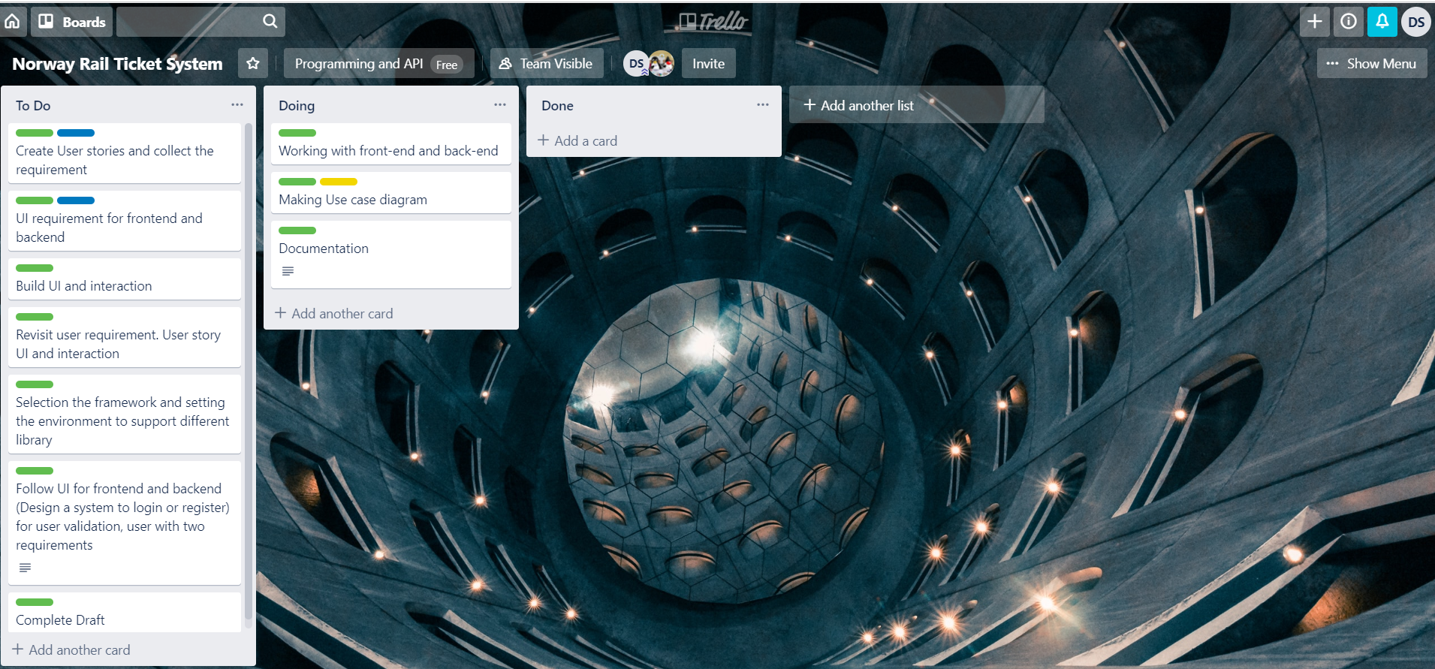

**Fig-1: trello dashboard for the project**

1. **System Architecture for Railways System**

As the system architecture provides the brief structure of the conceptual elements with their relationship and properties, it is an important part of project scalability, easy maintenance and reusability. For this state-of-art project, model, view and controller pattern is selected for the user interface and system design with both the front end and backend of this project.

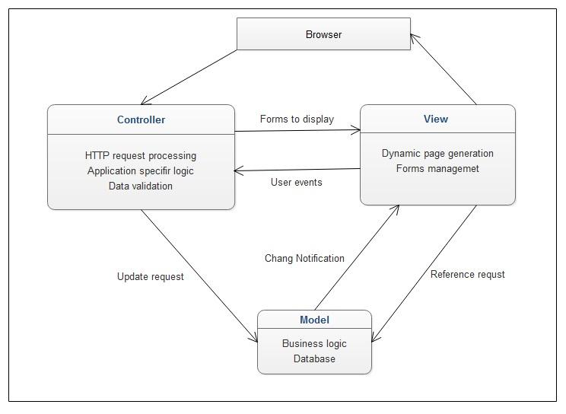

**Fig-2: MVC architecture patterns for web application**

* Model : presents the underlying logical structure of data and stores data and enforce all kind of business logic/rules that applies to the data.
* View: responsible of user interface
* Controller: The mediator between view and controller responsible for input, action on model and decision on what action to be performed such a rendering view or redirecting to another page.

1. **Use Case diagram and Universal Design Principles**

The concept of universal design is important while designing the software or any new technology as it bridges the gap between the all the users regardless of the users with their size, age, ability or disability. It benefits everyone, if a technology is accessible, usable, and convenient to use. Web content accessibility guidelines (WCAG 2.0) is the standard for web content accessibility that meets the needs of individuals, organizations and government internationally (Clements, 2002).  The guidelines are developed through World wide web consortium (W3C) process including the members and organization around the world to develop a web standard lead by Web inventor Tim Berner Lee and CEO Jeffery Jaffe("ABOUT W3C,"). Authoring tools accessible guideline (ATAG), User Agent Accessible guidelines (UAAG), WAI-ARIA are the guidelines for making the web content accessible for all ability of people including disabled people.

**Use Case Diagram**

It is a blueprint of the system that represents user interaction with the system and shows the relationship between the user and the different use cases. The main objective of use case diagram is to provide the high-level view of the functional and technical system and convey the requirement with additional diagram. The use case diagram of Norway railway system is shown below that shows the interaction between users and the system.

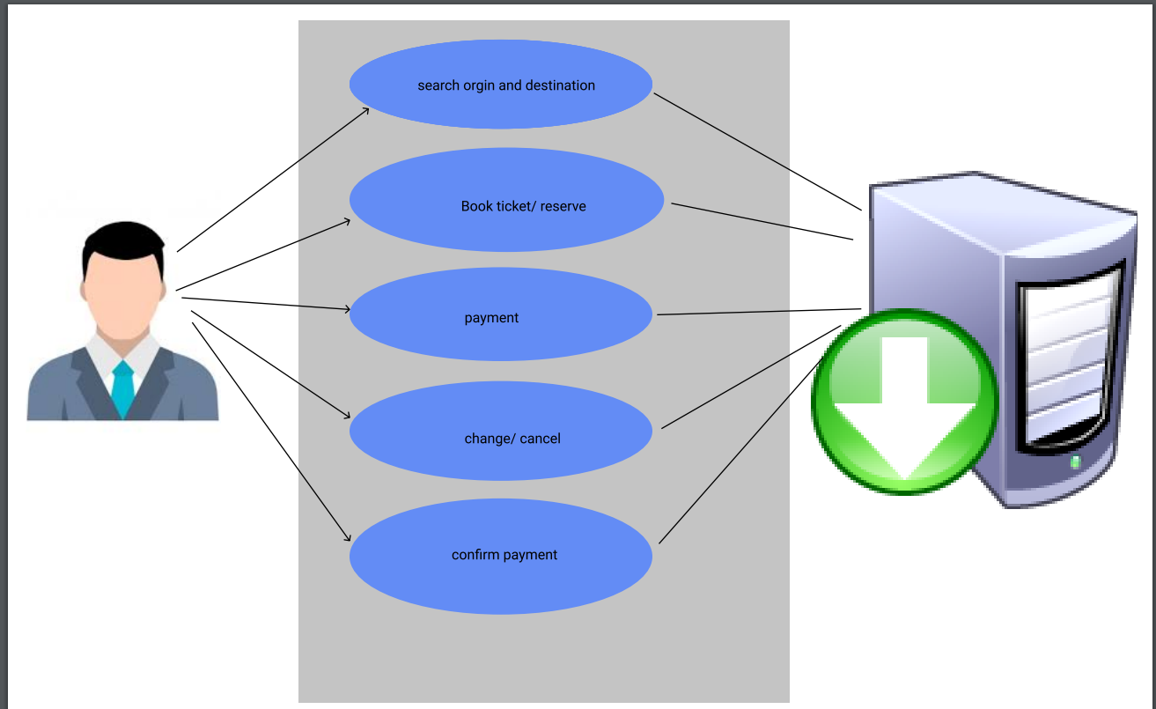

**Fig-3: use case diagram of Railway system.**

Figure shows the users, application functionality and the software system, that is being designed. In addition to that user is provided with date feature to select the available date for future booking and there is also the options for different age group i.e. child, adult, student or old.

1. **User Interface of Railways system**

The user interface of railway system contains simple background image for both the normal user and adim panel. Bootstrap with html5, css3 and JavaScript is used for designing the frontend of the user interface. The reserve button acts as initial point for user reservation of the ticket booking system.

Following figure shows the starting point of the user interface.

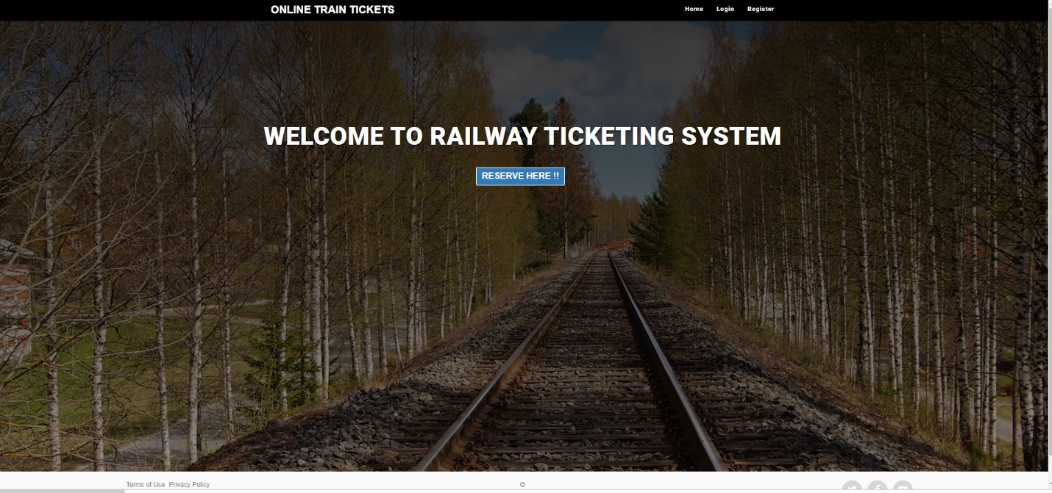

**Fig-4: Homepage of Railway ticketing**

The backend of the project is the database design using MySQL on WAMP apache server. MySQL is a structural query language to communicate with the data from user and provide the necessary query based on the user search. Due to its reliability, easy use and scalability for client server architecture, it is popular and widely used in many popular websites and also in embedded systems.

1. **Discussion and Future improvements**

During the initial phase of the project most of the hours is invested on api search but could not find the relevant one. However, the new api in web market can be new direction for this project. User verification is not completed for this project, however the project meets the requirements of the selected task. So, user verification can be added as improvement to the task. The time is another factor that can be added to make it more reliable. Due to time constraints the user registration could not be updated in database, which could be an additional feature of this project.

1. **Screen shots of the results**
   1. **User registration**

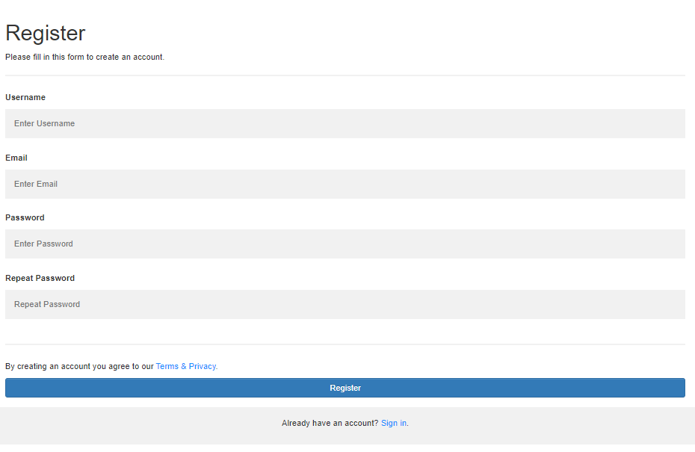

**Fig-5: User Registration**

* 1. **Select destination/ source**

Figure show the source and destination field after user presses the reserve button.

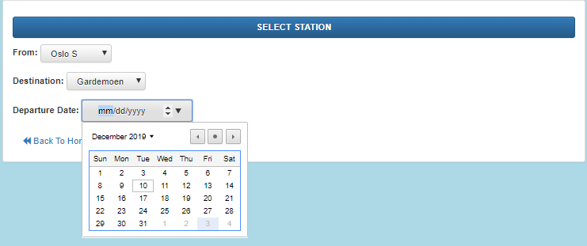

**Fig-6: Station selection**

* 1. **Selection accommodation/ number of passengers**

After user selects date, source and destination, user is provided with option for accommodation and number of passengers. Figure below shows the accommodation:

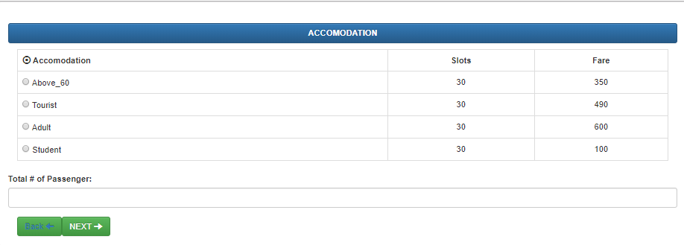

**Fig-7: Accommodation selection**

* 1. **Passenger Information**

After the user confirms accommodation, user is provided with form to register 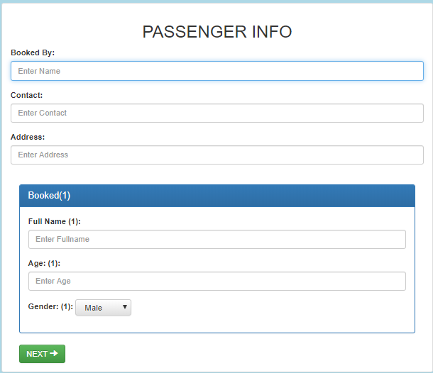name, age, and email for confirmation.

**Fig-8: Passenger Information**

* 1. **Confirmation/ success message**

The final step is the confirmation for the successful ticket booking. Figure below show the successful ticket booking.

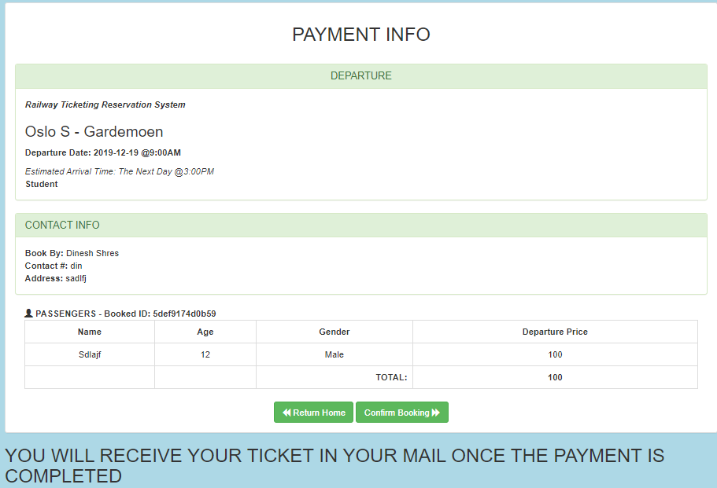

**Fig-9: Ticket Confirmation**

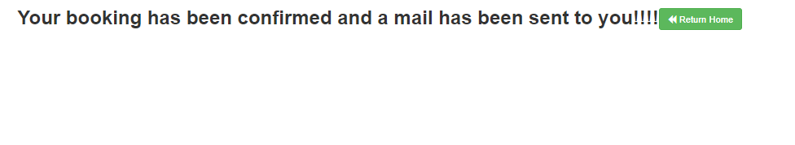

**Fig-10: Booking confirmation message**

* 1. **Admin login/ dashboard**

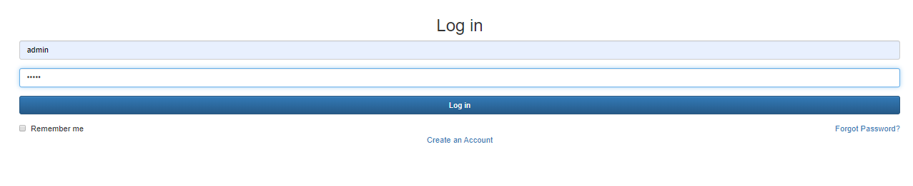

**Fig-11: Admin login**

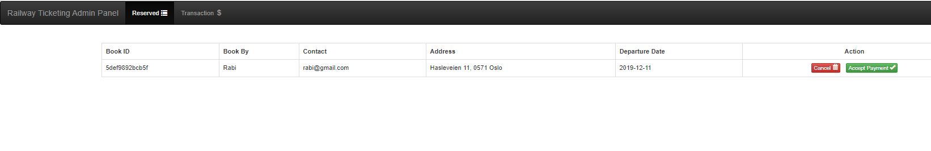

**Fig-12: Admin dashboard**

* 1. **Payment confirmation**

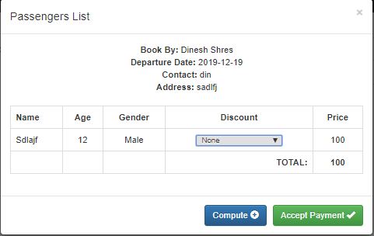

**Fig-13: Payment Confirmation**

1. **Conclusion**

The project fulfills the general requirement for the Norwegian railway ticketing system to update the obsolete system. The system automates the easy reservation and cancellation of the ticket with new high-level programming language and user-friendly design. Further improvement and new direction is provided in future improvement section.

# **References**

Alliance, A. (n.d.). *Agile Alliance*. From https://www.agilealliance.org/agile101/: https://www.agilealliance.org/agile101/

Clements, P. G. (2002). *ABOUT W3C. ABOUT W3C.* From https://www.w3.org/Consortium/.

Spolsky, J. (2011). *Trello*. From https://en.wikipedia.org/wiki/Trello: https://en.wikipedia.org/wiki/Trello